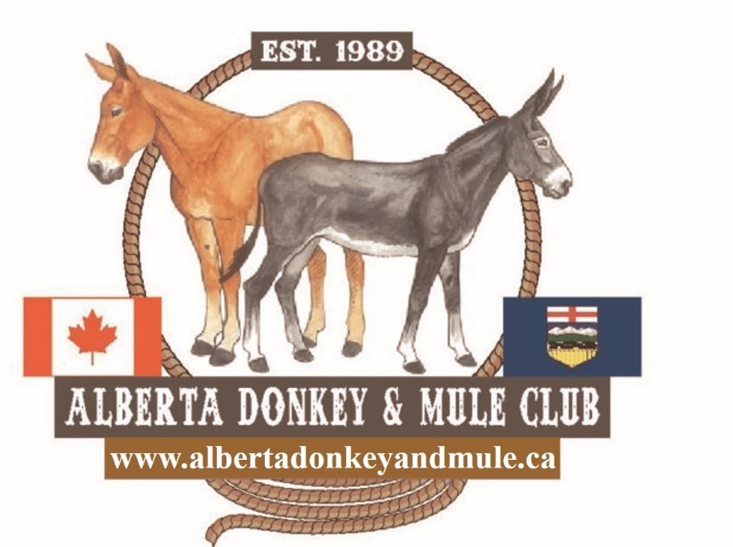

Open Fun Show
All Equines Welcome!

June 5, 6, 7 2026

THE POINTE
Sherwood Park
Judging by: Melissa Glowinski

Show Start 10am
PROFESSIONAL PHOTOGRAPHER
Valid AEF (or equivalent) Membership Required

Any questions please text Amanda at 780-722-6383 or email info@albertadonkeyandmule.ca

:
- ENTRIES: Pre-registration is mandatory. Entries to be sent to ADMC by either of the following:
  - info@albertadonkeyandmule.ca
b) 55323 Range Road 273 Sturgeon County, AB T8R 1X9

Entries close June 1, 2026

- FEES:
  - $13.00 per class or $130.00 for unlimited classes per horse/handler for the weekend.
Early bird registration for current ADMC members $100! – Register and pay by May 22. ADMC Membership $25, no long-ears required.
Please send payment via:
- E-transfer- info@albertadonkeyandmule.ca
- Cheque via mail- ADMC C/O Amanda Enmark as above.
- STABLING:
Stabling available. Stalls are $80/weekend
Extra shavings $11/bale. No outside shavings permitted.
- EQUINES: Age of equine shall be that reached during the calendar year 2026. All equines welcome! Stallions/Jacks not to be handled by anyone under 18. Must be in a chain and under control at all times. If this is not the case, they will be asked to leave the premises without refund.

EXHIBITORS:
- Age as of January 1, 2026
The same animal can be show by different handlers in different age categories
- Well-behaved dogs must remain on a leash and supervised at all times.

- HELMETS: Are encouraged and will never be penalized. All youth exhibitors must have properly fitted and certified helmets on when riding or working with livestock.

RULES:
- Have FUN and be SAFE
- ADMC, the Show Committee and The Pointe Ag Society will not be responsible for any loss, damage or injury to persons, equine, or property at this show.
- All classes are at the decision of the Judge. Classes may be merged or split based on participation numbers.
- Show clothes not required but welcome. Two hands welcome in all classes, as required for the animal and rider.
- No cross entry between walk trot and regular classes.

- Obstacle Race:
This fast-paced horsemanship based class will be loosely based on Extreme Cowboy Racing rules.

Each class will have a different pre-set course of 8-13 obstacles depending on the division. The judge will do a walk through with all the competitors before the start of each class. One at a time, each competitor will enter the arena and wait behind the start line. When the whistle blows, the rider may cross the start line and begin the course, 30 seconds are allowed to cross the start line. The judge will give a score for each obstacle out of 10, plus an overall horsemanship score out of 10, and time points will be awarded at one point per 20 seconds under 8 minutes. The obstacles will be judged on correctness, speed with control, and style. The obstacles must be completed in order. Each obstacle will have a 30 second time limit. If exceeded, the judge will blow the whistle to indicate that you must move on to the next obstacle. Horses being ridden must be in Western or Australian gear and attire. No nosebands, training aids, whips on a ridden horse, or bits with any gag action.
Divisions:
R1. In Hand - horses will complete obstacles in hand with no other equipment. Handlers may carry a whip. Scores will favor soft communication without touching the horse, horses being sent over obstacles without the handler, and speed with control. There will be 8 obstacles plus a horsemanship score and time points. Rope halters, nylon/leather halters, chain or rope lead ropes, or bridles are all allowed.
R2. Ground Driving - horses will complete the obstacles while being ground driven in either a harness or surcingle. Driver must carry a whip. Scores will favor soft communication, good body position behind the drive line, and speed with control. There will be 8 obstacles in this division plus a horsemanship score and time points. Horse may be driven in an open or closed bridle, or a halter. Lines MUST be split.
R3. Novice - This ridden division is for entry- level riders that have only just learned the basics of walk, trot, canter, and basic body control with or without obstacles, and have little to no experience or success in any discipline. The obstacles will be very basic. There will be 10 obstacles in this division plus a horsemanship score and time points.

R4. Intermediate - This division is for riders that have some experience with obstacles or in other disciplines, and are comfortable adding speed in some circumstances. The obstacles may have some added complexity. There will be 13 obstacles in this division plus a horsemanship score and time points.
R5. Open division - This division is for experienced obstacle racers. The obstacles will increase in difficulty. There will be 13 obstacles in this division plus a horsemanship score and time points.
Riders may choose up to two consecutive divisions. This event will be a great introduction to the sport and very friendly for first-time competitors!

- CLASS DESCRIPTIONS:

- DRIVING CLASSES –
-Ground Driving may not cross enter to a hitched class except for Green ass Grass.
-Ground-Driving and Reinsmanship patterns to be posted the evening prior to classes at show office.
-Junior drivers age 18 – 14 may drive a VSE (under 39”) alone. Ages 13 under must have a competent adult in the vehicle at all times. Helmets are mandatory for junior drivers.
-Pleasure classes to be shown both direction in walk, slow trot, regular trot and extended trot, halt and back readily.
-A whip must always be in hand when driving.
-Teddy Bear Class – Dress up your favorite teddy bear to join you for a class!
-Scurry – 4 x figure 8 around pilons. Fastest time wins.
- HALTER CLASSES – Any aged handler. Competitors may show more than one horse in a class provided they have people to hold the other horses.
- SHOWMANSHIP CLASSES – Patterns will be posted at show office the evening before classes.
- PLEASURE CLASSES – English and Western, each entry will be judged according to riding style and breed standard.
- COSTUME CLASS – Open to all ages.
- GAMES – More games may be added at no additional cost providing sufficient time.
- EQUITATION – English and Western, pattern will be posted at the show office.
- HUNTER – Over fences to be judged on way of going and technique over fences. Only 2 consecutive classes may be entered by any exhibitor.
- COON JUMPING – A long-ears classic! Animals are led and must establish a full halt in the “box” prior to attempting to jump.
- PANCAKE – Bring your own pancake mix! Firewood and other supplies will be provided. Make your best pancake for the judges to sample! One animal to a team of 2-3 people.

- PRIZES
- Rosettes to 6th place will be awarded
- Top Long Ear will be awarded in designated classes (see class lists) indicated by **
- Championship buckles will be awarded to: Top Driving Long Ears, Top Youth Handler, Top Ridden Long Ears (English and Western), and Top Overall Long Ears. Points accrued based on class placings.

Class List/Schedule:
Please note classes are based on attendance and
may be altered or merged
Friday, June 5, 2026
Obstacle Race
First Runs Start at 12:00 noon
R1. In Hand**
R2. Ground Drive**
R3. Novice**
R4. Intermediate**
R5. Open**

Saturday, June 6, 2026
Classes Start at 10 AM Sharp
1. Ground Driving Pattern**
2. Green ass Grass Pleasure Driving Single or Pair**
3. Reinsmanship – Open**
4. Junior Equine Pleasure Drive (Age 3-5)**
5. Junior To Drive - Single or Pair (under 18)**
6. Pleasure Drive Open – Single or Pair**
7. Teddy Bear Class – Single or Pair **
8. Scurry (Gound Drive/Hitched)**
LUNCH
English Division
- English Pleasure- Walk Trot- Junior – no cross entry
- English Pleasure Walk Trot- 18 Years and Older - no cross entry
- English Please Walk Trot Long Ears- All Ages - no cross entry
- English Pleasure- Junior
- English Pleasure- 18 years and Older
- English Pleasure Long Ears- All Ages
- English Equitation – Junior
- English Equitation – Senior
Break
- Poles and Cavaletti
- X-rails
- 0.5 m Hunter
- 0.6 m Hunter
- 0.75 m Hunter
- Coon Jumping Mini Long Ears (under 36”)
- Coon Jumping Standard Long Ears (36” – 56”)
- Coon Jumping Mammoth Long Ears (over 56”)

Class List, Sunday, June 7, 2026
Classes Start at 10 AM Sharp
- Halter- Donkey/Mule Junior 5- Animal (Mollies/Jennies)
- Halter- Donkey/Mule Senior 6+ Animal (Mollies/Jennies)
- Halter – Donkey/Mule Junior 5- Animal (Jacks/Johns)
- Halter – Donkey/Mule Senior 6+ Animal (Jacks/Johns)
- Long Ears Halter Championship (top 2 of classes 25 – 28)
- Halter- All Equine 2 and Under
- Halter- All Equine 3,4,5
- Halter- All Equine 6 and Over
- Showmanship- Junior Exhibitor**
- Showmanship- 18 Years and Older**

*Short Break to allow for tack up and warm up*

- Lead Line- 8 years and under
- Western Pleasure- Walk Trot- Junior – no cross entry
- Western Pleasure – Walk Trot – Senior – no cross entry
- Western Please Walk Trot Long Ears- All Ages - no cross entry
- Western Pleasure- Junior
- Western Pleasure - Senior
- Western Pleasure Long Ears- All Ages
- Western Equitation – Junior
- Western Equitation – Senior

LUNCH
- Costume Class
*Short break to change tack*
GAMES

- Barrel Race Junior**
- Barrel Race Senior**
- Egg and Spoon Race In- Hand**
- Egg and Spoon Race Ridden Junior**
- Egg and Spoon Race Ridden Senior**
- Toilet Paper Pairs**
- Musical Stalls (mounted)**
- Musical Stalls (in hand)**
- On Command**
- Ride a Fiver
Additional games may be run depending on time allowance (at no extra charge)
- The Pancake Class

** Top Long Ear will be recognized in the class

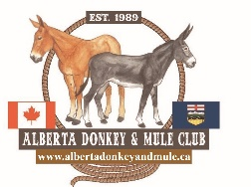
ADMC Fun Show Entry Form

Name: _________________________________ AEF Number:_______________________________

Address:

_________________________________________________________________

______________________________________________________________________________

Phone: ___________________________ Age (if under 18): ____________

Equine Name: _________________________________________________________________

Classes:

_____, _____, _____, _____, _____, _____, _____, _____, _____, _____, _____, _____, _____,

_____, _____, _____, _____, _____, _____, _____, _____, _____, _____, _____, _____, _____,

Stabling: $80/stall/weekend includes 2 bags shavings | # Stalls______ | Fees: $______
Stable with:
Extra shavings available at $11/bale. Outside shavings not permitted | # Extra Bales | Fees: $
Camping: $40/night powered, $20/night dry | # nights | Fees $

Entry Fee: $13.00 per class or $130.00 for the weekend (one equine and handler)
*Early Bird Day Fee for ADMC members if received by May 22, $100/weekend!
Total Classes $_________

Total Payment $________
Payments for pre-entry:
- E-transfer- info@albertadonkeyandmule.ca
- Cheque via mail- ADMC C/O Amanda Enmark 55323 RR 273, Sturgeon County, AB T8R 1X9

*Refunds will be given if vet/doctor note provided prior to start of show day. No refunds after first class begins.

